Arduino IDE

Open Aruino IDE choose Board:
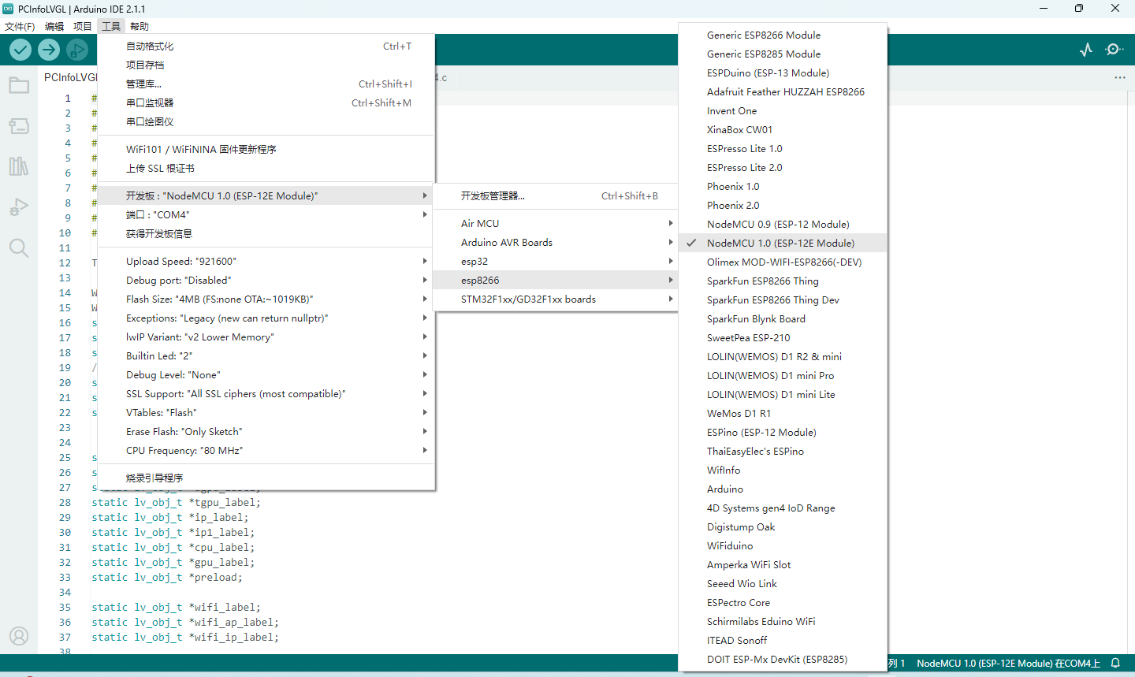

Choose Path Library Arduino to Project path:

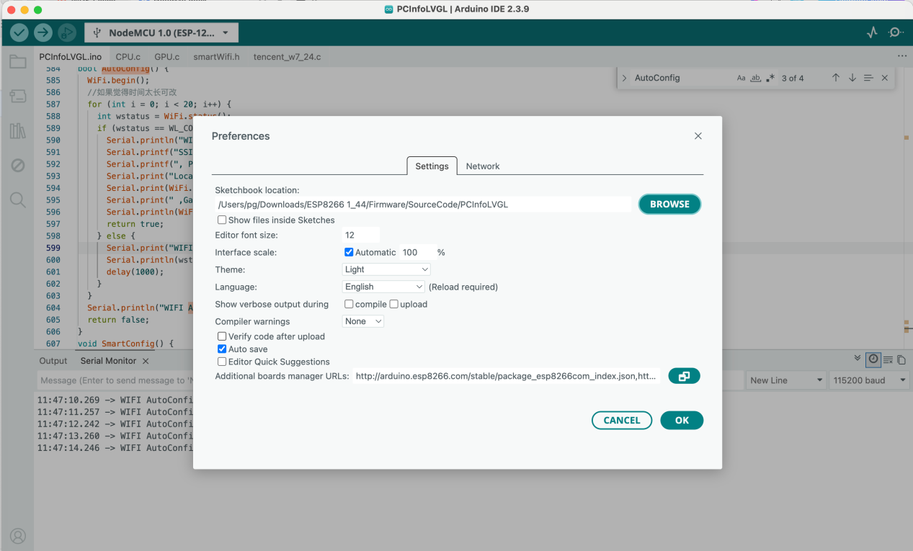

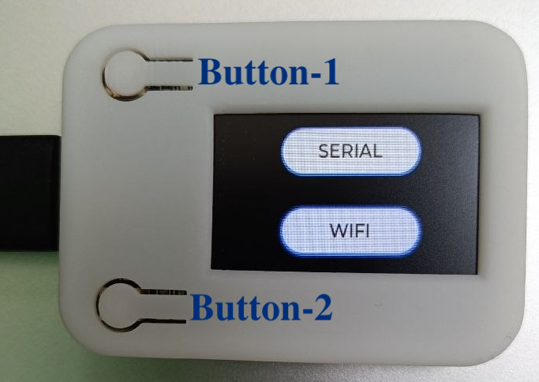
- Push Button-1 Choose Serial => Software will connect to board by serial
- Push Button-1 Choose WIFI => Software will connect to board by wifi

